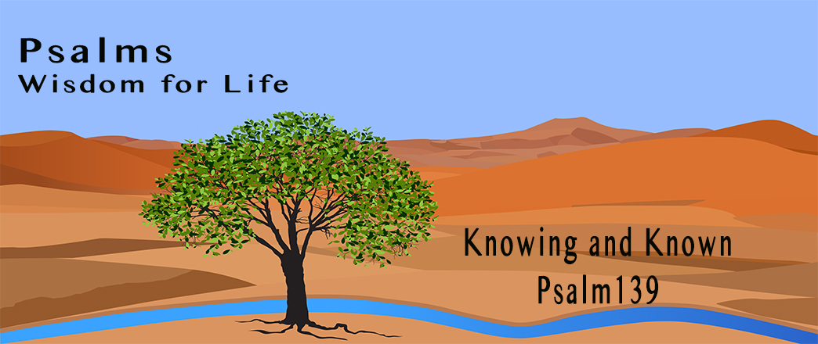
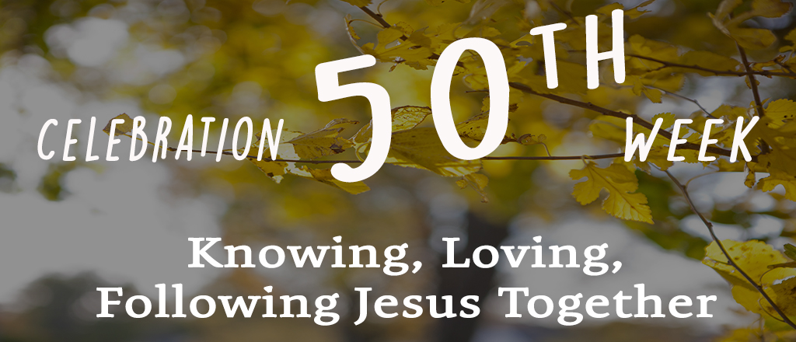

OCTOBER 15 & 16, 2017

HOLY LAND TOUR APRIL 9 – 18, 2018 – You are invited to join Rev. Jim & Suzy Erb, of Lena EFC on this Holy Land trip. Visit www.eo.travel or call 800/247-0017 for more information. Brochures are available at the Welcome Center.

HOW GOD TURNED THE WORLD UPSIDE DOWN! This biblically-based training will reveal how the Apostles changed the world and how we have access to the same source. Saturday, November 18, at New Life Bible Church. Registration begins at 8:30am, conference ends at 4:00 pm. Call 815/547-0765 for more information. Brochures are available at the Welcome Center.

SHARE YOUR STORY - Park Hills Church wants to hear the story of how God has been at work in your life. Everyone's story is unique and has the power to impact others. If you are interested in sharing your story and having it published on our website, please go to www.parkhillsefc.org and click on "Share Your Story".

MEAL MINISTRY – If you would be willing to make a meal for someone recovering from an illness or surgery, please contact Wendy 815/541-5204 or Charmaine 815/821-5211.

PRAYER SHAWL MINISTRY – We will be meeting on October 25th at 9:00 am in the Elevator Room. We continue to work on shawls and lap robes for our church family, as well as the community. We are also working on lap robes and shawls to be distributed to a local nursing home on Valentines Day. Please join us! New members and ideas are always welcome. Questions? Contact Linda Long 815/369-4895 or Dianne Statdfield 815/233-4826 for more information.

ITEMS NEEDED FOR UPCOMING HONDURAS MISSION TRIP – Adult and children’s vitamins (NO gummies please), ibuprofen 200 mg, hair pretties for girls & Hot Wheels/Match Box cars for boys. Donations may be left in the bin in the Lobby. Thank You! Questions, contact Rod Wedel at 815/291-7608.

FAITH COMMUNITY NURSE (FCN) – FCN’s will be doing free blood pressure screenings again on Sunday October 22 & November 26 between services (9:45 – 10:30 am) in the Music Room Annex (there will be no screenings offered in December).

FACC (Freeport Area Church Cooperative) is asking for donations of pasta noodles for October. Donations may be left in the bin in the Lobby. Thank you for your continued generosity!

SMALL GROUP/BIBLE STUDY OPPORTUNITIES:
- TUESDAY MORNING MOMS’ BIBLE STUDY meets in the Music Room from 9:30-11:00 am, studying Colliding with Destiny - Finding Hope in the Legacy of Ruth by Sarah Jakes. Childcare is provided. Questions? Please contact Heidie Kuhlemeier 815/541-8011 or Carol Elliott 815/232-6495.
- WEDNESDAY MORNING LADIES BIBLE STUDY is meeting at 10:00 am in Room 202, studying the Gospel of John. All women are invited to participate, as well as their friends. Questions, call Judy Fosler 815/280-8786 for more information.
- THURSDAY EVENING LADIES BIBLE STUDY meets through November 16, from 6:30 – 8:00 pm in the Library, studying All Things New: A Study on II Corinthians by Kelly Minter. Contact Carol at 815/232-6495 for more information.
- THURSDAY EVENING MENS BIBLE STUDY meets from 6:30 -8:00 pm, in the Elevator Room, studying Kingdom Man by Tony Evans. Contact Kurt Bales 815/238-8541 for more information.
- FRIDAY EVENING SINGLE LADIES SMALL GROUP meets from 6:00-7:30 pm in the Library, studying 12 Women of the Bible. For more information, call Carol at 815/291-9478.
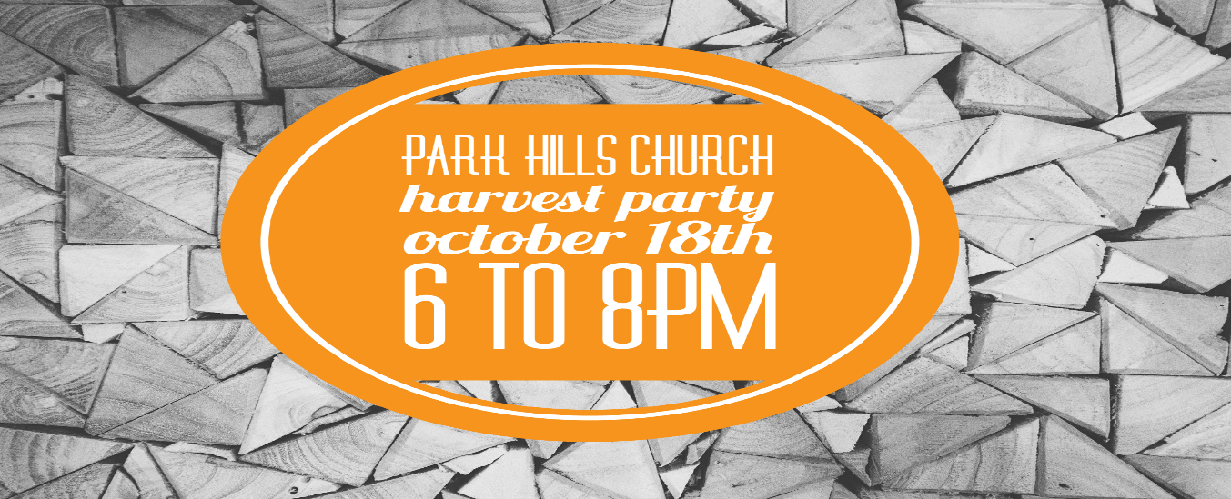

JOIN US FOR HARVEST WEEK, OCTOBER 15 – 22
AS WE CELEBRATE 50 YEARS OF MINISTRY

SUNDAY, OCTOBER 15 - CONGREGATIONAL MEETING at 6:00 pm, in the Worship Center. All regular attenders of Park Hills Church are encouraged to join us. We particularly need all members to attend in order for us to vote on the selection of new elders and to review and approve the 2018 church budget. Meeting info packets are available in the Lobby, pick up your copy today!

MONDAY, OCTOBER 16 - A DAY OF FASTING - feel free to fast and pray with us as we seek God for the day and practice one of the spiritual disciplines we talked about this spring. Pick up your fasting guide at the Welcome Center!

TUESDAY, OCTOBER 17 - 24 HOURS OF PRAYER – We aim to fill 24 hours of continuous prayer. Please sign up at the Welcome Center for a 15 minute time slot. You may pray at home or in the Worship Center during office hours. Please pick up your prayer guide at the Welcome Center!

WEDNESDAY, OCTOBER 18 - HARVEST PARTY - This year's annual HARVEST PARTY will be a church-wide event, an opportunity to invite neighbors, family and friends to celebrate some fall fun with free food and games! The party on Wednesday, October 18th, from 6:00 to 8:00 pm, will be a part of Park Hills Church's larger 50th anniversary celebration, called Harvest Week. This evening will be a place to build on relationships for the sake of the Good News! Invitations are available at the Welcome Center to hand out. We want to greet and serve as many folks as possible, so we need LOTS of help. We are looking for set up, tear down, greeters, food servers, parking lot attendants, games and more. We also need PRIZES-think candy, stuffed animals, trinkets, etc. Please sign up at the Welcome Center, or online at www.parkhillskids.com. We hope you can join the team!

THURSDAY, OCTOBER 19 - THE CASE FOR CHRIST - Ask a friend to "Explore the Evidence for Yourself". Join us for the showing of this powerful movie at 7:00 pm, in the Worship Center. Tickets are available at the Welcome Center.

SATURDAY, OCTOBER 21 – Pick up THE REVIVED HEARTS AND LIVES DEVOTIONAL at the Welcome Center to study together in the comfort of your own home.

SUNDAY, OCTOBER 22 - Consider who you will invite to join us for Sunday services as we conclude our celebration of 50 years.

PARK HILLS EVANGELICAL FREE CHURCH
2525 W STEPHENSON ST - FREEPORT, IL 61032 815-232-6159
Office Hours: M-Th 9 am - 4 pm & Fri 9 am - 12 pm

CHECK OUT MONDAY NIGHT CHURCH 6:30 pm in the Chapel!

READING PLANS FOR OUR LUKE SERIES ARE AVAILABLE at the Welcome Center, the church website (www.parkhillsefc.org) and the church app.

CONNECT CARD – If you are new to our church, have an address or phone number change, have a prayer concern, or would like more information about Park Hills, please fill out one of the connect cards found in the chair pockets and drop it in the offering plate.

NEW TO PARK HILLS? – Stop by the Welcome Center for more information about our church! We would love to meet you!

ADULT SUNDAY SCHOOL OPPORTUNITIES:
- RAY VANDER LAAN DVD SERIES ON THE HOLY LAND - taught by Dale Miner & Bill Kuhlemeier, 9:00 - 10:00 am in the Library.
- HEBREWS - taught by Pastor Cliff, 10:00 - 11:15 am in the Chapel.

SUNDAY MORNINGS for KIDS:
Parents and families, following are your children's Sunday morning options, designed to give your children a deeper experience in God's word, no matter which service they attend.
- 8:45 a.m. one combined nursery (ages birth through 3 years), staffed with volunteers who really love caring for your little ones.
- 8:45 a.m. one combined class (ages 3 years through 5th grade) that follows the same topic as the sermon to allow for families to have meaningful conversations throughout the week on what we are all learning.
- 10:30 a.m. two age-appropriate nursery options. (Parents decide when it is suitable for their three-year-olds to move up to the next class).
- 10:30 a.m. three age-appropriate (ages 3 years through 5th grade) classes, that make use of the entire service time. You are able to drop off your children with their teachers in their classrooms starting at 10:15 a.m.
- We support your decision as families to attend service together. Children are always welcome in the service.

MIDWEEK OPTIONS FOR CHILDREN AND STUDENTS— Something for everyone in your family!
WEDNESDAY NIGHTS: 6:30 to 8:00 pm/check out Awana @ www.parkhillskids.com and CORE @ www.parkhillsyouth.com/CORE
- Puggles (18 months thru 3 years)
- Cubbies (3 and 4 years)
- Sparks (K thru 2nd grade)
- T&T (3rd through 6th grade)
- CORE (middle school - 6th through 8th grade)
TUESDAY NIGHTS: Frontline (high school) 6:30 to 8:00 pm - check out www.parkhillsyouth.com/frontline.

“SECOND HALF” is a ministry at Park Hills composed of retired and semi-retired individuals who have a heart for serving within our church family. The members of Second Half recognize their God-given talents and this ministry is one of the ways they continue to use those gifts. In the short time of our existence, multiple projects have been completed with more being planned. These opportunities have been a blessing to those who have worked together. Please contact the church office with any questions about this ministry.

DID YOU KNOW our website (www.Parkhillsefc.org) and our app (parkhillschurch) contain a video and audio copy of the weekly sermon? You will also find a copy of the latest Sermon Based Small Group (SBSG) questions on the website. Audio and video copies will be available each Tuesday afternoon.

