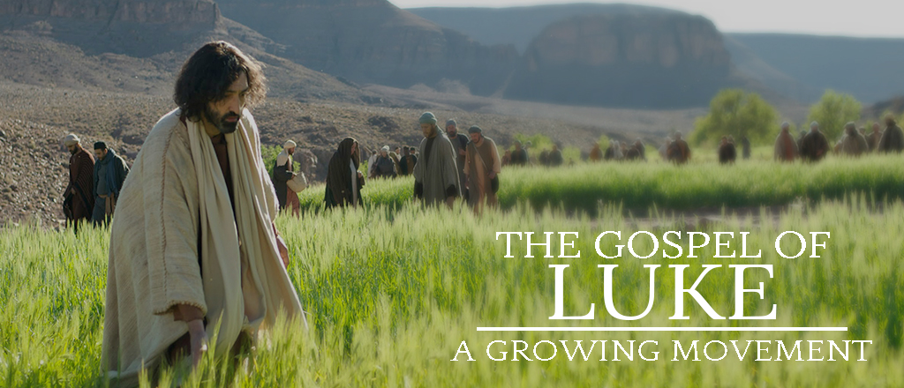
January 28, 2018

HEARTFELT THANKS – Words cannot express our gratitude to our church family for all the prayers said on my behalf during my heart attack & bypass surgery. Thank you for all the phone calls, cards, visits, prayer shawl, afghan & food. Continue to pray for me as I still have some healing to do and much strength to get back. God is so good! God Bless you. – Nancy Vorwald & family

THE 11th ANNUAL CHILI COOK-OFF IS COMING NEXT Sunday, February 4! You won’t want to miss the Annual Park Hills Chili Cook-Off – hosted in the gym. This event is a fundraiser for our student ministries Myrtle Beach Spring Break trip and Challenge Missions Conference trip. You will enjoy (and judge) the best chili/soup in town! If you would like to enter the chili cook-off contest – please sign up at the Welcome Center or on-line at parkhillsefc.org/ministries/park-hills-teens

ALL AWANA VOLUNTEERS BREAKFAST - Enjoy a yummy breakfast on us, Saturday, February 10th, from
8:30 – 11:00 am in the Chapel. This will be a time to fellowship with your team members and to also meet some new friends from other clubs, outside of the action of club night. If you have been interested in volunteering for AWANA, join us this morning to learn more about ways to serve and meet the team! Please let us know that you will be coming. SIGN UP at the Welcome Center or by Connie on Wednesday nights.

TRI-COUNTY CHRISTIAN SCHOOL OPEN HOUSE – Choosing a school for your child is one of the most important decisions you will ever make. If you are looking for biblical worldview teaching and academic excellence, please consider TCCS. Open house for grades pre-k through 8th grade, Tuesday, February 6th, 6:30-8:00 pm. 2900 W Loras Dr. Freeport. Questions? Call the school office at 815/233-1876.

THE OUTDOOR PURSUIT SPORTSMAN’S BANQUET - On Saturday, March 17th, some 200+ men will be treated to an evening of great food, a sportsman’s raffle and will hear nationally known author, outdoor writer and pastor, Zeke Pipher, speak on “How to be Good at Being a Man.” Limited tickets on sale TODAY in the Lobby for $20/person or online at parkhillsefc.org/ministries/mens-ministry

LIFE & DEATH MATTERS: We are planning a “mini-seminar” on Saturday, February 17, from 8:30 AM – 12:30 PM in the Chapel. Get some expert advice in the areas of legal, medical, spiritual and end of life care issues. Sessions led by: Dr. Rebecca Pedersen, FHN Hospice Medical Director; Peter J. McClanathan, Attorney at Law, Fishburn, Whiton, Thruman Ltd.; PH pastoral panel on “Christian Perspectives on Death”; and “Choices in Senior Living” Fair. If you or a family member need help in any of these areas this is your chance to be informed by local professionals in a relaxed, comfortable, no pressure setting. Don’t miss out!! Registration Required!! Sign up at the Welcome Center or online at parkhillsefc.org/ministries/adult-ministries

PRAYER SHAWL MINISTRY – We will have the next meeting this Wednesday, January 31, at 9:00AM in the Elevator Room. We will be working on the Pocket Prayer Squares for Pearl Pavillion. Please join us, new members are always welcome. Questions? Call Linda Long 815/369-4895 or Dianne Statdfield 815/238-6629.

SAVE THE DATE! - SpringHill Day Camp is coming back to Park Hills Church this summer, July 30th - August 3rd, 2018! REGISTRATION opens February 14th. Register early to save (www.springhilldaycamps.com).

MISSION TRIP – There is a 10-day mission trip being planned to Belarus in May of 2018. The purpose will be to add a sanctuary to an existing building. For more information, contact Warren Stultz at 815/520-6506.

FAITH COMMUNITY NURSE (FCN) – FCN’s will be doing free blood pressure screenings TODAY, January 28th between services (9:45 – 10:30 am) in the Music Room Annex.

FACC (Freeport Area Church Cooperative) is asking for donations of spaghetti sauce, canned tomato products, shampoo, toothpaste, deodorant and body wash for the month of January. Donations may be left in the bin in the Lobby. Thank you for your continued generosity!

GREAT LAKES DISTRICT HURRICANE CRISIS TRIPS – EFCA regional superintendent, Daniel Grell is organizing and leading two district trips which individuals can join. The first trip will leave on Saturday, March 3rd, with a return on Saturday, March 10th. The team will travel to and assist with hurricane recovery in the Corpus Christi area alongside Bayshore Bible Church (EFCA). The second trip will leave on Saturday, April 28th, with a return on Saturday, May 5th. The team will travel to and assist with hurricane recovery in the Houston area. If you are interested in joining one of the GLD hurricane recovery trips alongside other individuals from churches across the GLD, please contact Daniel Grell at dgrell49@gmail.com for further details.

GALENA BIBLE CHURCH – On Saturday, February 3rd, Galena Bible Church will be hosting the 25th annual No Regrets Men’s Conference. For more information on this event visit www.galenabiblechurch.org or pick up a flier from the Welcome Center.

SENIOR RESOURCE CENTER – Want to learn more about your prescription medications? Come to “Ask the Pharmacist” from 2 to 3 pm, Tuesday, January 30th, at the Senior Activity Center, 216 E. Stephenson St. Please register early for this free event by calling Monroe Clinic at 877/865-1462 or emailing monroeclinic.org.

DID YOU KNOW? – NOW you can view and/or listen to the weekly sermons on our PH mobile app (parkhillschurch) and website (www.parkhillschurch.com). You can also download a copy to your computer or mobile device for listening offline! You will also find the Sermon Based Small Group Questions (SBSG) and the weekly bulletin in electronic form on the mobile app each Sunday morning.

MEAL MINISTRY – If you would be willing to make a meal for someone recovering from an illness or surgery, please contact Wendy 815/541-5204 or Charmaine 815/821-5211.

“SECOND HALF” is a ministry at Park Hills composed of retired and semi-retired individuals who have a heart for serving within our church family. The members of Second Half recognize their God-given talents and this ministry is one of the ways they continue to use those gifts. In the short time of our existence, multiple projects have been completed with more being planned. These opportunities have been a blessing to those who have worked together. Please contact the church office with any questions about this ministry.

CONNECT CARD – If you are new to our church, have an address or phone number change, have a prayer concern, or would like more information about Park Hills, please fill out one of the connect cards found in the chair pockets and drop it in the offering plate.

READING PLANS FOR OUR LUKE SERIES ARE AVAILABLE at the Welcome Center, the church website (www.parkhillschurch.com) and the church app.

SMALL GROUP/BIBLE STUDY OPPORTUNITIES:
- TUESDAY MORNING MOMS’ BIBLE STUDY meets in the Music room from 9:30 – 11:00 am, studying What Women Fear: Walking in Faith That Transforms by Angie Smith. Childcare is provided. If you have questions, please contact Heidie at 815/541-8011 or Carol at 815/232-6495.
- WEDNESDAY MORNING WOMEN’S BIBLE STUDY - We will resume our Gospel of John study, THIS WEEK, Wednesday, January 17, at 10am. Anyone interested may join us in Room 202. This session will be taught by Diane Dawson. Questions, call Diane at 815/275-3082.
- THURSDAY EVENING MEN’S SMALL GROUP - This group will begin THIS WEEK, Thursday, January 18, from 6:30 – 8:00 pm, in the Elevator Room. We will be studying “Manhood Restored” by Eric Mason. If interested, please sign up at the Welcome Center. Questions?, contact Kurt Bales 815/238-8541.
- FRIDAY EVENING SINGLE LADIES STUDY – February 2 – April 20 we will be studying 12 More Women of the Bible: (cost of the book is $7). We will be meeting in Room 301 from 6:00 – 8:30 pm. Please sign up at the Welcome Center. If you have questions, contact Carol Mehlhausen at 815/291-9478.

ADULT SUNDAY SCHOOL OPPORTUNITIES:
- RAY VANDER LAAN DVD SERIES ON THE HOLY LAND - taught by Dale Miner & Bill Kuhlemeier, 9:00 - 10:00 am in the Library.
- HEBREWS - taught by Pastor Cliff, 10:00 - 11:15 am in the Chapel.

PARK HILLS EVANGELICAL FREE CHURCH
2525 W STEPHENSON ST - FREEPORT, IL 61032 815-232-6159
Office Hours: M-Th 9 am - 4 pm & Fri 9 am - 12 pm

CHECK OUT MONDAY NIGHT CHURCH 6:30 pm in the Chapel!

SUNDAY MORNINGS for KIDS:
Parents and families, following are your children's Sunday morning options, designed to give your children a deeper experience in God's word, no matter which service they attend.
- 8:45 a.m. one combined nursery (ages birth through 3 years), staffed with volunteers who really love caring for your little ones.
- 8:45 a.m. one combined class (ages 3 years through 5th grade) that follows the same topic as the sermon to allow for families to have meaningful conversations throughout the week on what we are all learning.
- 10:30 a.m. two age-appropriate nursery options. (Parents decide when it is suitable for their three-year-olds to move up to the next class).
- 10:30 a.m. three age-appropriate (ages 3 years through 5th grade) classes, that make use of the entire service time. You are able to drop off your children with their teachers in their classrooms starting at 10:15 a.m.
We support your decision as families to attend service together. Children are always welcome in the service.

MIDWEEK OPTIONS FOR CHILDREN AND STUDENTS— Something for everyone in your family!

WEDNESDAY NIGHTS for 18months thru 6th grade
Check out AWANA 6:30 to 8:00 pm
www.parkhillskids.com
Puggles (18 months thru 3 years)
Cubbies (3 and 4 years)
Sparks (K thru 2nd grade)
T&T (3rd through 6th grade)

WEDNESDAY NIGHTS for MIDDLE SCHOOL STUDENTS 6th – 8th grade
Check out CORE 6:30 to 8:00 pm
www.parkhillsyouth.com/CORE

TUESDAY NIGHTS for HIGH SCHOOL STUDENTS
Check out Frontline 6:30 to 8:00 pm
www.parkhillsyouth.com/frontline

