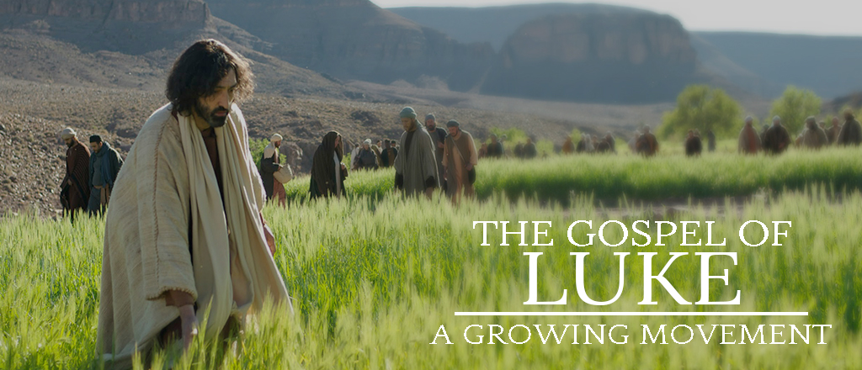
February 18, 2018

SAFE FAMILIES BABY SHOWER FOR THE MONTH OF FEBRUARY - You will notice that we are collecting items for our Safe Families host homes and children in the Lobby this month. As we serve families in our community in crisis by hosting vulnerable children in our Park Hills Church homes, we need your help. We are collecting diapers (any size), wipes, socks and underwear (NEW-in small kids’ sizes), gift cards for Aldi, Walmart or CVS, toothbrushes, children's books (new) and blankets or pillows (new) to have on hand so we are ready when host homes get the call to host. Thank you for considering supporting our host homes by providing these necessary items! Visit the Lobby and grab a tag to help you remember to shop this week. You can bring the items back to the Lobby any Sunday in February. THANK YOU!

WE NEED YOUR HELP! The Sermon Team is planning a panel discussion on March 11th. We will focus on concepts concerning demonic activity and healing. Jesus' ministry starts to focus on these things more and more in the weeks to come, and we would love to know if you have specific questions about these topics that we can deal with. Send questions to chris.stukenberg@parkhillsefc.org and we will address all we can in the time allotted.

MARRIAGE: WHAT DID YOU EXPECT? If you want to enjoy a beautiful relationship with your spouse, you will need something deeper than romantic acts and shared interests. You will need realistic expectations and daily commitments. Join us, here in the Chapel, Friday, March 2, 6:00 - 9:00pm & Saturday, March 3, 9:00 am – 12:00 pm, for a video event with marriage expert and best-selling author, Dr. Paul David Tripp, as he shares two questions and commitments we need to have at the center of our marriage relationship. A family pizza dinner & free childcare will be provided on Friday, March 2. Sign up at the Welcome Center or online.

WOMEN’S THURSDAY EVENING BIBLE STUDY will begin March 8 – April 12. Join us for What Love Is – The Letters of 1, 2, & 3 John by Kelly Minter. This 6 - week study will include a DVD presentation, discussion, and daily Bible study lessons. We will be meeting in the Library from 6:30 -8:00 pm. Sign up at the Welcome Center. Questions? Call Carol Elliott 815/232-6495.

THE OUTDOOR PURSUIT SPORTSMAN’S BANQUET - On Saturday, March 17th, some 200+ men will be treated to an evening of great food, a sportsman’s raffle and will hear nationally known author, outdoor writer and pastor, Zeke Pipher, speak on “How to be Good at Being a Man.” Limited tickets on sale TODAY in the Lobby for $20/person or online at parkhillsefc.org/ministries/mens-ministry

DAY CAMP REGISTRATION IS OPEN!!! SpringHill Day Camp is returning this July! Your campers (completed Kindergarten through 5th grade) are invited for an AMAZING week of summer camp, right here in Freeport at Park Hills Church! Think about your young neighbors, grandchildren, nieces and nephews, July 30th - August 3rd, (Monday-Friday) 9:00 am to 4:00 pm. We want your kids to experience new things, make new friends, learn about God and create lifelong memories together! Save $20 per camper if you register NOW through February 28th (final day to get last year’s prices). Visit www.springhilldaycamps.com to register today.

BIG DADDY WEAVE CONCERT – Enjoy a special night of music at the Freeport Masonic Temple with Big Daddy Weave & Brandon Heath. Concert is Saturday, March 17, at 7:00 pm, tickets are $20. More information is available at bit.ly/BDWFreeport.

MISSION TRIP – There is a 10-day mission trip being planned to Belarus in May. The purpose will be to add a sanctuary to an existing building. For more information, contact Warren Stultz at 815/520-6506.

FACC (Freeport Area Church Cooperative) is asking for donations of canned fruit for the month of February. Donations may be left in the bin in the Lobby. Thank you for your continued generosity!

PRAYER SHAWL MINISTRY – We will have the next meeting February 28 at 9:00AM in the Elevator Room. We will be working on the Pocket Prayer Squares for Pearl Pavillion. Please join us, new members are always welcome. Questions? Call Linda Long 815/369-4895 or Dianne Statdfield 815/238-6629.

FAITH COMMUNITY NURSE (FCN) – FCN’s will be doing free blood pressure screenings again NEXT Sunday, February 25, between services (9:45 – 10:30 am) in the Music Room Annex.

HEAL GRIEF SUPPORT GROUP – HEAL grief and education group offers sessions open to anyone 18 yrs and older who have experienced the death of someone special. Learn about the grieving process and ideas for coping and healing in a safe and supportive setting. This 6 - week session will begin THIS Wednesday, February 21, 9:00 – 10:30 am. At St. Camillus Center, 2101 6th St. Monroe, WI. Please call the Monroe Clinic Hospice office to register 608/324-1230, more information at www.monroeclinic.org

SMALL GROUP/BIBLE STUDY OPPORTUNITIES:
- TUESDAY MORNING MOMS’ BIBLE STUDY meets in the Music room from 9:30 – 11:00 am, studying What Women Fear: Walking in Faith That Transforms by Angie Smith. Childcare is provided. If you have questions, please contact Heidie at 815/541-8011 or Carol at 815/232-6495.
- WEDNESDAY MORNING WOMEN’S BIBLE STUDY meets in Room 202 at 10am. Anyone interested may join us. This session will be taught by Donna Herring. Questions, call Donna at 815/908-1079.
- THURSDAY EVENING MEN’S SMALL GROUP meets in the Elevator Room from 6:30 – 8:00 pm. We are studying “Manhood Restored” by Eric Mason. Questions, contact Kurt Bales 815/238-8541.
- FRIDAY EVENING SINGLE LADIES STUDY meets in Room 301 from 6:00 – 8:30pm. We are studying 12 More Women of the Bible. If you have questions, contact Carol Mehlhausen at 815/291-9478.

PARK HILLS EVANGELICAL FREE CHURCH
2525 W STEPHENSON ST - FREEPORT, IL 61032 815-232-6159
Office Hours: M-Th 9 am - 4 pm & Fri 9 am - 12 pm

CHECK OUT MONDAY NIGHT CHURCH 6:30 pm in the Chapel!

ADULT SUNDAY SCHOOL OPPORTUNITIES:
- RAY VANDER LAAN DVD SERIES ON THE HOLY LAND - taught by Dale Miner & Bill Kuhlemeier, 9:00 - 10:00 am in the Library.
- HEBREWS - taught by Pastor Cliff, 10:00 - 11:15 am in the Chapel.

SUNDAY MORNINGS for KIDS:
Parents and families, following are your children's Sunday morning options, designed to give your children a deeper experience in God's word, no matter which service they attend.
- 8:45 a.m. one combined nursery (ages birth through 3 years), staffed with volunteers who really love caring for your little ones.
- 8:45 a.m. one combined class (ages 3 years through 5th grade) that follows the same topic as the sermon to allow for families to have meaningful conversations throughout the week on what we are all learning.
- 10:30 a.m. two age-appropriate nursery options. (Parents decide when it is suitable for their three-year-olds to move up to the next class).
- 10:30 a.m. three age-appropriate (ages 3 years through 5th grade) classes, that make use of the entire service time. You are able to drop off your children with their teachers in their classrooms starting at 10:15 a.m.
We support your decision as families to attend service together. Children are always welcome in the service.

MIDWEEK OPTIONS FOR CHILDREN AND STUDENTS— Something for everyone in your family!

WEDNESDAY NIGHTS for 18months thru 6th grade
Check out AWANA 6:30 to 8:00 pm
www.parkhillskids.com
Puggles (18 months thru 3 years)
Cubbies (3 and 4 years)
Sparks (K thru 2nd grade)
T&T (3rd through 6th grade)

WEDNESDAY NIGHTS for MIDDLE SCHOOL STUDENTS 6th – 8th grade
Check out CORE 6:30 to 8:00 pm
www.parkhillsyouth.com/CORE

TUESDAY NIGHTS for HIGH SCHOOL STUDENTS
Check out Frontline 6:30 to 8:00 pm
www.parkhillsyouth.com/frontline

CONNECT CARD – If you are new to our church, have an address or phone number change, have a prayer concern, or would like more information about Park Hills, please fill out one of the connect cards found in the chair pockets and drop it in the offering plate.

READING PLANS FOR OUR LUKE SERIES ARE AVAILABLE at the Welcome Center, the church website (www.parkhillschurch.com) and the church app.

MEAL MINISTRY – If you would be willing to make a meal for someone recovering from an illness or surgery, please contact Wendy 815/541-5204 or Charmaine 815/821-5211.

“SECOND HALF” is a ministry at Park Hills composed of retired and semi-retired individuals who have a heart for serving within our church family. The members of Second Half recognize their God-given talents and this ministry is one of the ways they continue to use those gifts. In the short time of our existence, multiple projects have been completed with more being planned. These opportunities have been a blessing to those who have worked together. Please contact the church office with any questions about this ministry.

DID YOU KNOW? – NOW you can view and/or listen to the weekly sermons on our PH mobile app (parkhillschurch) and website (www.parkhillschurch.com). You can also download a copy to your computer or mobile device for listening offline! You will also find the Sermon Based Small Group Questions (SBSG) and the weekly bulletin in electronic form on the mobile app each Sunday morning.

