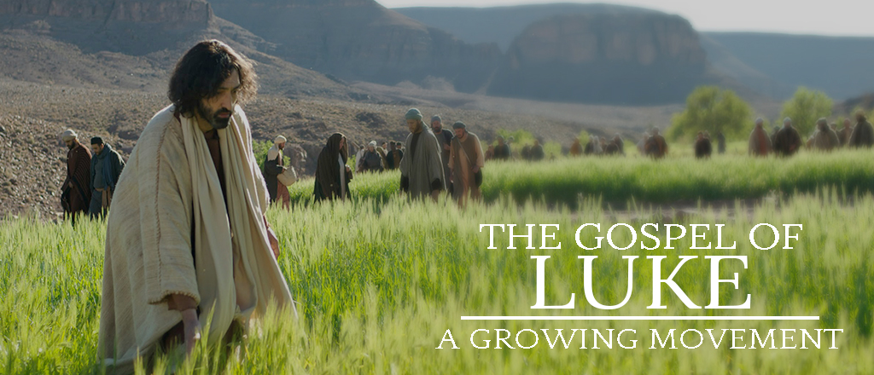

April 15, 2018

CONGRATULATIONS –
- Gene & Mary Anne Erdmier celebrated their 65th wedding anniversary on April 12th!

AWANA YEAR END CELEBRATION - This AWANA club year has been a lot of fun and a lot of learning from God's Word! We thank this church family for the way you have supported and encouraged us. We will be hosting our YEAR END CELEBRATION on Wednesday, May 2nd, in the Worship Center at 6:30 pm. Join us for a recap of how we have grown and a fun ice cream treat afterwards! Everyone is welcome to attend! We are looking for volunteers to set up and serve ice cream for the celebration starting at 6:15 pm. Please sign up at the Welcome Center today.

SPRINGHILL DAY CAMP IS RETURNING THIS JULY! Your campers (completed Kindergarten through 5th grade) are invited for an AMAZING week of summer camp, right here in Freeport hosted at Park Hills Church!
We want your kids to experience new things, make new friends, learn about God and create lifelong memories together! Think about your children, young neighbors, grandchildren, nieces and nephews, Monday – Friday, July 30th - August 3rd, at9:00 am to 4:00 pm. If you have questions, or to inquire about a scholarship for your child, please contact Merri Lane at merri.lane@parkhillsefc.org. Visit www.springhilldaycamps.com to register (you can sign up for a payment plan).
SPONSOR A CAMPER! Our church family extends an invite to campers in the community that would not be able to get to camp due to cost. If you can help, please drop a gift of any amount into the offering plate MARKED SPRINGHILL, or go to www.parkhillskids.com and donate to sponsor a camper. (A full week of camp is $199).

VBS IN YOUR BACKYARD THIS SUMMER - Would you like to build relationships based on Jesus with the children and families around you? We are looking for BACKYARDS to host our five-day Vacation Bible Schools, and would love to bring a VBS into your neighborhood, via your home/yard. SIGN UP is coming SOON! You will be able to sign up for a time slot for the weeks of June 18th OR June 25th (Monday- Friday), and your event could be hosted in the morning, afternoon, or evening, depending on your schedule.

BLENDED AND BLESSED/KEYS TO STEPFAMILY SUCCESS – THIS Saturday, April 21st, from 9:00 am - 4:30 pm, we will host a FREE one-day event and livestream for stepfamily couples, single parents, dating couples with kids, and those who care about blended families. Over 13,000 people from 22 countries experienced the 2017 event. With some of today’s most trusted and respected experts, Blended & Blessed will challenge, inspire, and encourage you. Register TODAY at the Welcome Center or online at parkhillschurch.com.
FACC (Freeport Area Church Cooperative) is asking for donations of canned corn for the month of April. Donations may be left in the bin in the Lobby. Thank you for your continued generosity!

READING PLANS FOR OUR LUKE SERIES ARE AVAILABLE at the Welcome Center, the church website (www.parkhillschurch.com) and the church app.

DID YOU KNOW? – NOW you can view and/or listen to the weekly sermons on our PH mobile app (parkhillschurch) and website (www.parkhillschurch.com). You can also download a copy to your computer or mobile device for listening offline! You will also find the Sermon Based Small Group Questions (SBSG) and the weekly bulletin in electronic form on the mobile app each Sunday morning.

MEAL MINISTRY – If you would be willing to make a meal for someone recovering from an illness or surgery, please contact Wendy 815/541-5204 or Charmaine 815/821-5211.

FAITH COMMUNITY NURSE (FCN) – FCN’s will be doing free blood pressure screenings again, NEXT Sunday, April 22, between services (9:45 – 10:30 am) in the Music Room Annex.

PRAYER SHAWL MINISTRY LUNCHEON – Our next meeting is our luncheon! We will meet Monday, April 23, at 11:15 am at the Country Junction. We will NOT be meeting on Wednesday, April 25th. Our last meeting for this semester will be Wednesday, May 30. New members are always welcome! Call Linda Long 815/369-4895 or Dianne Statdfield 815/238-6629.

ADULT SUNDAY SCHOOL OPPORTUNITIES:
- RAY VANDER LAAN DVD SERIES ON THE HOLY LAND - taught by Dale Miner & Bill Kuhlemeier, 9:00 - 10:00 am in the Library.
- HEBREWS - taught by Pastor Cliff, 10:00 - 11:15 am in the Chapel.

SUNDAY MORNINGS for KIDS:
Parents and families, following are your children's Sunday morning options, designed to give your children a deeper experience in God's word, no matter which service they attend.
- 8:45 a.m. one combined nursery (ages birth through 3 years), staffed with volunteers who really love caring for your little ones.
- 8:45 a.m. one combined class (ages 3 years through 5th grade) that follows the same topic as the sermon to allow for families to have meaningful conversations throughout the week on what we are all learning.
- 10:30 a.m. two age-appropriate nursery options. (Parents decide when it is suitable for their three-year-olds to move up to the next class).
- 10:30 a.m. three age-appropriate (ages 3 years through 5th grade) classes, that make use of the entire service time. You are able to drop off your children with their teachers in their classrooms starting at 10:15 a.m.
We support your decision as families to attend service together. Children are always welcome in the service.

_____________________________________________________
PARK HILLS EVANGELICAL FREE CHURCH
2525 W STEPHENSON ST - FREEPORT, IL 61032 815-232-6159
Office Hours: M-Th 9 am - 4 pm & Fri 9 am - 12 pm

CHECK OUT MONDAY NIGHT CHURCH 6:30 pm in the Chapel!

MIDWEEK OPTIONS FOR CHILDREN AND STUDENTS
Something for everyone in your family!

WEDNESDAY NIGHTS for 18months thru 6th grade
Check out AWANA 6:30 to 8:00 pm
www.parkhillskids.com
Puggles (18 months thru 3 years)
Cubbies (3 and 4 years)
Sparks (K thru 2nd grade)
T&T (3rd through 6th grade)

WEDNESDAY NIGHTS for MIDDLE SCHOOL STUDENTS 6th – 8th grade
Check out CORE 6:30 to 8:00 pm
www.parkhillsyouth.com/CORE

TUESDAY NIGHTS for HIGH SCHOOL STUDENTS
Check out Frontline 6:30 to 8:00 pm
www.parkhillsyouth.com/frontline

SMALL GROUP/BIBLE STUDY OPPORTUNITIES:
- TUESDAY MORNING MOMS’ BIBLE STUDY meets in the Music room from 9:30 – 11:00 am, studying What Women Fear: Walking in Faith That Transforms by Angie Smith. Childcare is provided. If you have questions, please contact Heidie at 815/541-8011 or Carol at 815/232-6495.
- WEDNESDAY MORNING WOMEN’S BIBLE STUDY meets in Room 202 at 10 am. Anyone interested may join us. Questions? Call Judy Fosler, 815/280-8786.
- FRIDAY EVENING SINGLE LADIES STUDY meets in Room 301 from 6:00 – 8:30 pm. We are studying 12 More Women of the Bible. If you have questions, contact Carol Mehlhausen at 815/291-9478.

“SECOND HALF” is a ministry at Park Hills composed of retired and semi-retired individuals who have a heart for serving within our church family. The members of Second Half recognize their God-given talents and this ministry is one of the ways they continue to use those gifts. In the short time of our existence, multiple projects have been completed with more being planned. These opportunities have been a blessing to those who have worked together. Please contact the church office with any questions about this ministry.

